UNIT – I : Basic Building Blocks in Python
CO1: Apply basic Python constructs, data types, operators, conditional and looping statements.
Q.No | Assignment Title | Full Assignment Question | Mapped CO
Q1 | Student Management System (Basic) | Develop a Python program to accept student details such as name and marks of subjects. Calculate total marks, average, and grade using conditional statements. Use proper indentation and comments. | CO1
Q2 | College Management System (Basic) | Write a Python program to store and display college details such as college name, department name, number of students and faculty using variables, data types, and formatted output. | CO1
Q3 | Electronics Tools Management System | Develop a menu-driven Python program to calculate total cost of electronic tools using arithmetic operators and conditional statements. | CO1
Q4 | Document Organizer | Create a Python program that accepts document name and document type and classifies the document category using if-else or else-if ladder. | CO1
Q5 | Simple Calculator | Develop a menu-driven calculator that performs arithmetic operations using loops and decision-making statements. | CO1

Sol
1.
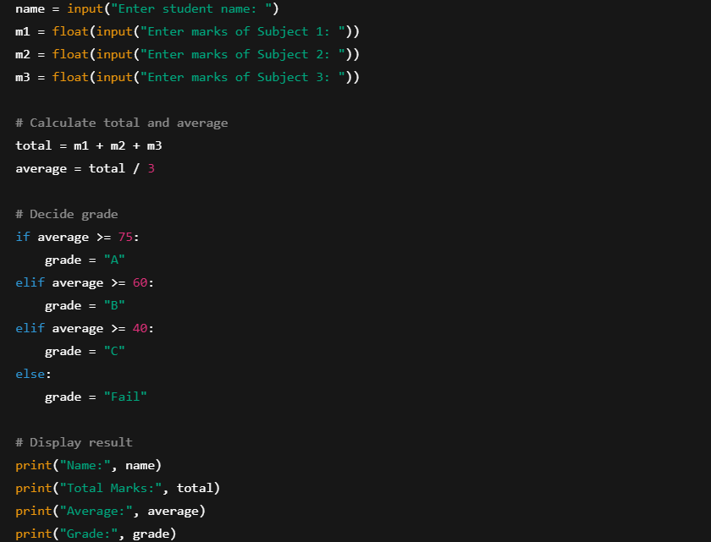

2.
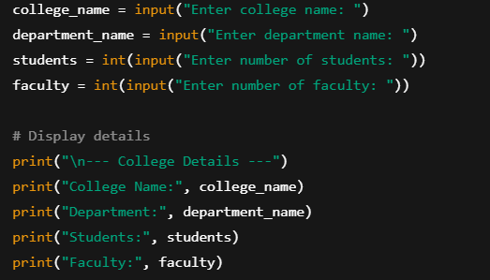
3.
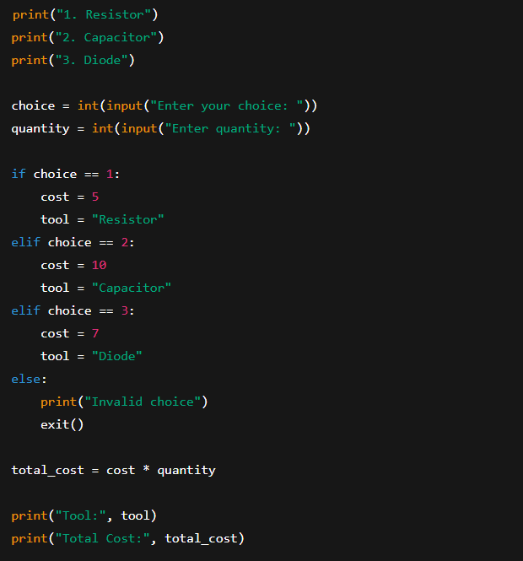
4.
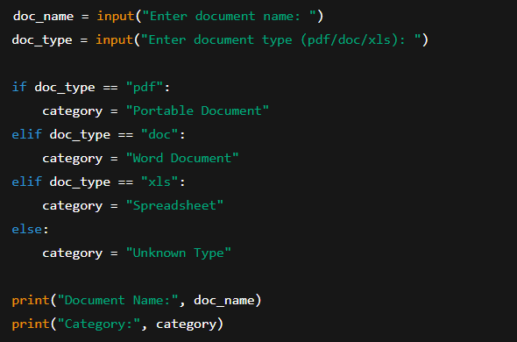
5.
